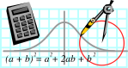  Rossmoyne SHS  Mathematics  Department | MATHEMATICS  3A MAT | Semester 1 2011  EXAMINATION

NAME:
TEACHER: Belonogoff Benko Fletcher Goh Longley Pui

(Circle one name) Rigelsford Robinson Tanday Tay White Whyte

Section One:
Calculator-free

Time allowed for this section
Reading time before commencing work: 5 minutes
Working time for this section: 50 minutes

Material required/recommended for this section

To be provided by the supervisor
This Question/Answer Booklet
Formula Sheet

To be provided by the candidate
Standard items: pens, pencils, pencil sharpener, eraser, correction fluid, ruler, highlighters

Special items: nil

Important note to candidates
No other items may be used in this section of the examination. It is your responsibility to ensure that you do not have any unauthorised notes or other items of a non-personal nature in the examination room. If you have any unauthorised material with you, hand it to the supervisor before reading any further.

Structure of this paper

Section | Number of questions available | Number of questions to be answered | Working time (minutes) | Marks available
Section One:  Calculator-free | 10 | 10 | 50 | 40
Section Two:  Calculator-assumed |  |  | 100 | 80
 |  |  |  | 120

Instructions to candidates

1. The rules for the conduct of Western Australian external examinations are detailed in the Year 12 Information Handbook 2011. Sitting this examination implies that you agree to abide by these rules.

2. Answer the questions in the spaces provided.

Section One: Write answers in this Question/Answer Booklet. Answer all questions.
Show all your working clearly. Your working should be in sufficient detail to allow your answers to be checked readily and for marks to be awarded for reasoning. Incorrect answers given without supporting reasoning cannot be allocated any marks. For any question or part question worth more than two marks, valid working or justification is required to receive full marks. If you repeat an answer to any question, ensure that you cancel the answer you do not wish to have marked.

It is recommended that you do not use pencil, except in diagrams.

3. You must be careful to confine your responses to the specific questions asked and to follow any instructions that are specific to a particular question.

4. Spare pages are included at the end of this booklet. They can be used for planning your responses and/or as additional space if required to continue an answer.
- Planning: If you use the spare pages for planning, indicate this clearly at the top of the page.
- Continuing an answer: If you need to use the space to continue an answer, indicate in the original answer space where the answer is continued, i.e. give the page number. Fill in the number of the question(s) that you are continuing to answer at the top of the page.

QUESTION | MARKS AVAILABLE | STUDENT MARK
1 | 5
2 | 3
3 | 2
4 | 3
5 | 7
6 | 5
7 | 5
8 | 3
9 | 2
10 | 5
TOTAL | 40

SECTION A
NO CALCULATORS PERMITTED FOR THIS SECTION
TIME 50 minutes
AVAILABLE MARKS 40 marks

Question 1 (1,2,1,1 marks)

(a) Determine the possible value/s of x in each of the following:

(i) 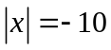

(ii) 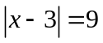

(b) Solve the following equations:

(i) 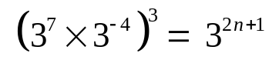

(ii) 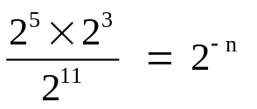

Question 2 (2,1 marks)

(a) Determine the equation of the function, f(x), below:
f(x)
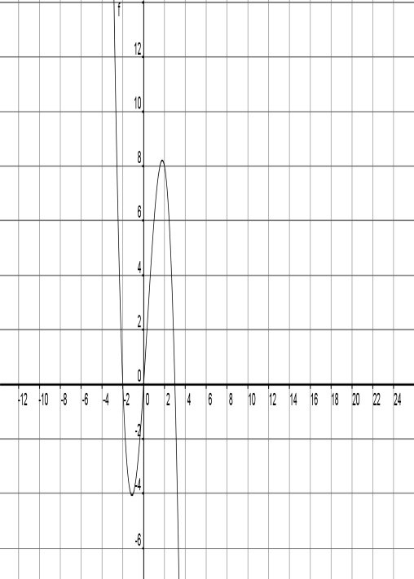

(b) Hence, solve 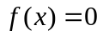.

Question 3 (2 marks)

(a) A sequence is defined recursively as:

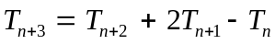 where 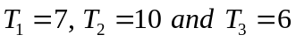

Determine the fourth and fifth terms of the sequence.

Question 4 (1,2 marks)
Shade the following descriptions on the Venn Diagrams provided.

(a) 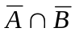  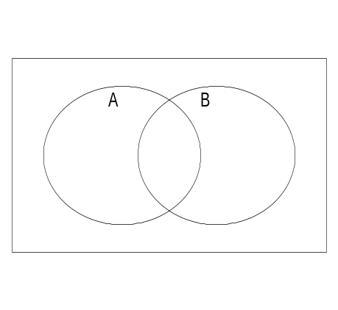 | (b) 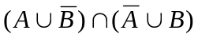  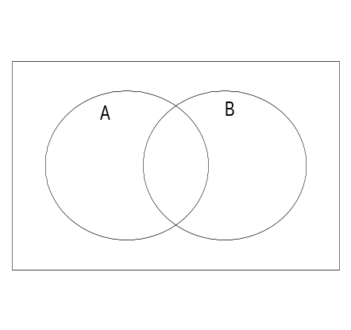

Question 5 (1,1,1,1,1,1,1 marks)

For the diagrams on the right (below),

(a)

(i) Write an equation that will allow you to solve for the value of x. (Do NOT solve it.)
59°
x°

3.5 cm
4.0 cm
(Diagram not drawn to scale)

(ii) Given that 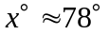 is a solution to the equation in (i) above. State another value of 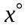, in degrees, (if any) that will satisfy the same given measurements? Explain why you were able or not able to find another value of in this situation.

(b) Write an equation that will allow you to solve for y. (Do NOT solve it).
80°
y m
65°
494 m
572 m
(Diagram not drawn to scale)

(c) Use the unit circle diagram below to determine the approximate value of each of the following trigonometric ratios:
0.5
-0.5

-0.5

0.5
x
y
1
-1

1

-1
20°
30°
20°

(i) sin 20º

(ii) sin 160º

(iii) cos 50º

(iv) cos 130º

Question 6 (5 marks)

If Q = {odd numbers}, R = {prime numbers} and U (the universal set) is the set of
digits, :

(a) Complete the Venn diagram below to show this information.

R
Q
U

(b) Determine:

(i) 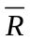

(ii) 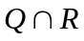

(iii) 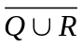

(iv) 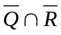

Question 7 (1,1,1,1,1 marks)

In order to finish her driver’s licence test, Dolly has to answer three ‘true’ or ‘false’ questions.

(a) Use a tree diagram to show all the possible ways Dolly could answer the questions.
(Use T = true and F = false)

If she gets more than one wrong, she fails the test. If the correct answer for each question was ‘True’ (T), determine the probability of:

(b) getting all three correct

(c) passing the test

(d) passing the test if she knew the answer to the first question

(e) getting one question wrong given that Dolly passed the test

Question 8 (1,1,1 marks)

Six members of the Math Quest Prize Winners have to arrange themselves in line for a photograph.
The members are: Aaron, Bree, Charlie, Dylan, Evelyn and Freddy.

How many arrangements are there in which:
(You may leave your answer in factorial form.)

(a) Aaron is at the left end?

(b) Aaron is at the left end or Freddy is at the right end?

(c) Aaron and Freddy are not next to each other?

Question 9 (2 marks)

Holly scores 26, 35 and 19 marks in three assessments in mid term, respectively. If the mean and standard deviation in each of these assessments are as given below, determine if she has improved in her performance? Justify your answer.

Assessment 1: | mean 34 | standard deviation 8
Assessment 2: | mean 32 | standard deviation 6
Assessment 3: | mean 17 | standard deviation 2.5

Question 10 (3,2 marks)

(a) Determine the median, lower quartile and upper quartile for the following set of scores:

20, 29, 17, 28, 27, 17, 30, 23, 30, 28, 21, 17

(b) Draw the box plot for the set of scores in (a) above on the grid below.

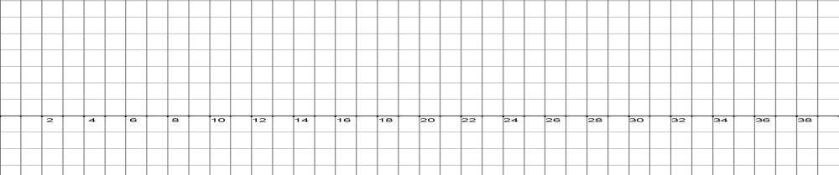

End of Part A

